### Build An Employee Travel Approval Application For Corporates (Admin)

The project aim is to provide real-time knowledge for all the students who have basic knowledge of Salesforce and Looking for a real-time project. This project will also help to those professionals who are in cross-technology and wanted to switch to Salesforce with the help of this project they will gain knowledge and can include into their resume as well.   
  
**What you'll learn**

1. Real-Time Salesforce Project
2. Object & Relationship in Salesforce
3. **Milestone 1- Create Salesforce Org**

Introduction   
   
Are you new to Salesforce? Not sure exactly what it is, or how to use it? Don’t know where you should start on your learning journey? If you’ve answered yes to any of these questions, then you’re in the right place. This module is for you.   
   
Welcome to Salesforce! Salesforce is game-changing technology, with a host of productivity- boosting features, that will help you sell smarter and faster. As you work toward your badge for this module, we’ll take you through these features and answer the question, “What is Salesforce, anyway?”   
   
What Is Salesforce?   
   
Salesforce is your customer success platform, designed to help you sell, service, market, analyze, and connect with your customers.   
   
Salesforce has everything you need to run your business from anywhere. Using standard products and features, you can manage relationships with prospects and customers, collaborate and engage with employees and partners, and store your data securely in the cloud.   
   
So what does that really mean? Well, before Salesforce, your contacts, emails, follow-up tasks, and prospective deals might have been organized something like this:   
 <https://youtu.be/r9EX3lGde5k>

1. **Creating Developer Org**
2. **Creating a developer org in salesforce.**   
      
   1. Go to developers.salesforce.com/   
   2. Click on sign up.   
   3. On the sign-up form, enter the following details:   
   1. First name & Last name   
   2. Email   
   3. Role: Developer   
   4. Company: College Name   
   5. County: India   
   6. Postal Code: pin code   
   7. Username: should be a combination of your name and company   
           This need not be an actual email id, you can give anything in the format:   
           username@organization.com   
      
   Click on sign up after filling these.
3. 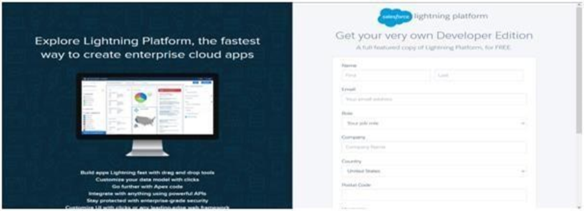
4. Salesforce Customer Secure Login Page. Login to your Salesforce Custom..
5. Salesforce Customer Secure Login Page. Login to your Salesforce Customer Account...
6. <https://login.salesforce.com/>
7. **Object In Salesforce**
8. Salesforce objects are database tables that permit you to store data that is specific to an organization. Salesforce objects are of two types: Standard Objects: Standard objects are the kind of objects that are provided by salesforce.com such as users, contracts, reports, dashboards, etc.   
   Salesforce objects are of two types:   
      
   1. Standard Objects: Standard objects are the kind of objects that are provided by salesforce.com such as users, contracts, reports, dashboards, etc.   
   2. Custom Objects: Custom objects are those objects that are created by users. They supply information that is unique and essential to their organization. They are the heart of any application and provide a structure for sharing data.
9. **Creation Of Department Object For Travel Approval App**
10. For this Travel Approval we need to create 5 objects   **Department, Employee Detail, Expense, Expense Items,** and**Travel Approval**. The below steps will assist you in creating those objects.   
       
    Create Department Object:  
       
    1. Click on the gear icon and then select Setup.   
    2. Click on the object manager tab just beside the home tab.   
    3. After the above steps, have a look on the extreme right you will find a Create Dropdown click on that and select Custom Object.   
    4. On the Custom Object Definition page, create the object as follows:   
    5. Label: Department   
    6. Plural Label: *Departments*   
    7. Record Name: *Department Name*   
    8. Check the Allow Reports checkbox   
    9.    Check the Allow Search checkbox   
    10.   Click Save.   
      
    In the same way create 4 more objects **Employee Detail, Expense, Expense Items**, and **Travel Approval**
11. **Note –**   
    1. While making Expense Object select data type “Auto Number” in “Enter Record Name  Label and Format” section.   
    2. While making Employee Detail Object put “Employee Name” in “Enter Record Name  Label and Format” section.   
      
    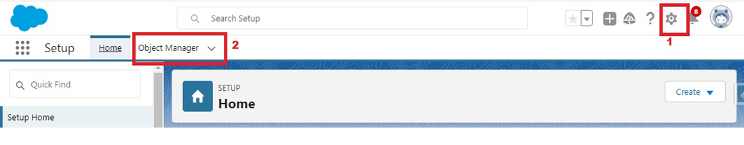  
    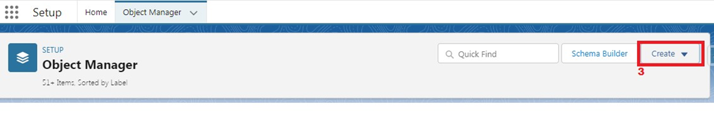  
      
    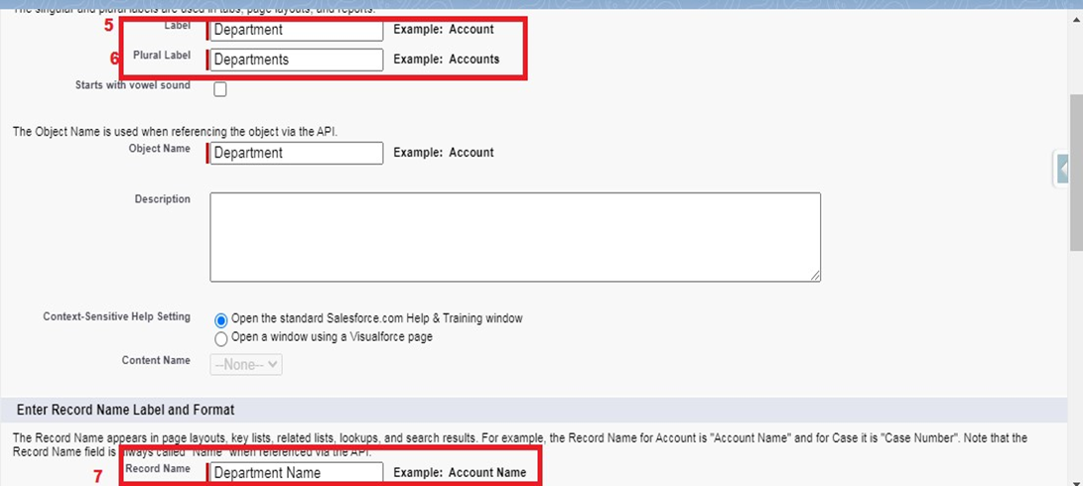  
      
      
    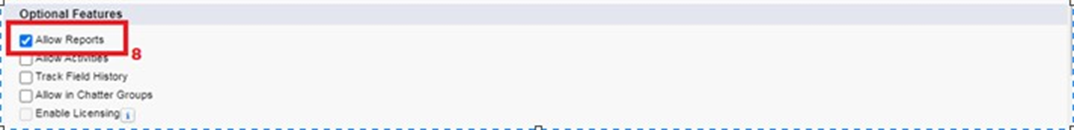  
      
      
    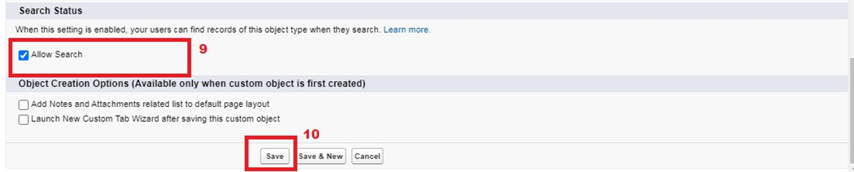
12. **What Is A Tab?**
13. Tabs in Salesforce help users view the information at a glance. It displays the data of objects and other web content in the application.   
       
    There are mainly 4 types of tabs:   
       
    (A) Standard Object Tabs: Standard object tabs display data related to standard objects   
       
    (B) Custom Object Tabs:  Custom object tabs displays data related to custom objects.    
       
    (C) Web Tabs: Web Tabs display any external Web-based application or Web page in Salesforce tabs.   
       
    (D) Visualforce Tabs: Visualforce Tabs display data from a Visualforce Page.
14. **Lightning App**
15. Apps in Salesforce are a group of tabs that help the application function by working together as a unit. It has a name, a logo, and a particular set of tabs. The simplest app usually has just two tabs.   
    There are two types of apps -   
      
    1. Standard App: Standard apps come with every occurrence of Salesforce as default. Many features like Sales, Marketing, Community, call center, content, Salesforce Chatter, App   Launcher, etc are present in it.   
    Note: The description, Logo, and Label of the standard app cannot be altered.   
       
    2. Custom Apps: Custom apps are created according to the needs of the user. Custom Apps are made by using standard and custom tabs together.
16. Note: Logos for Custom Apps can be changed.

**Create Travel Approval App**

**Create the Travel Approval app**

1. From Setup, enter App Manager in the Quick Find and select App Manager.
2. Click New Lightning App.
3. Enter **Travel Approval** as the App Name, then click Next
4. Under App Options, leave the default selections and click Next.
5. Under Utility Items, leave as is and click Next.
6. From Available Items, select **Department, Employee Detail, Expense, Expense Items, Travel Approval, Reports, and Dashboards** and move them to Selected Items. Click Next.
7. From Available Profiles, select System Administrator and move it to Selected Profiles.Click Save & Finish.

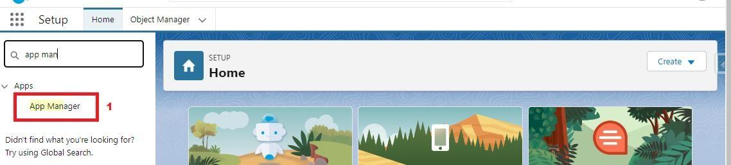  
  
  
  
  
  
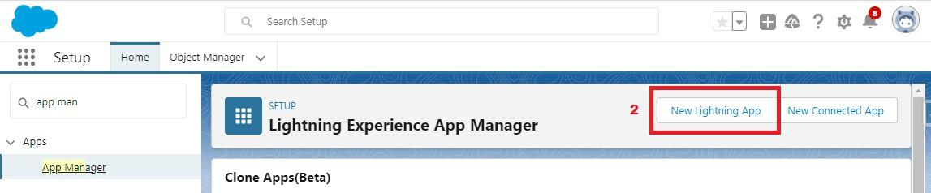  
  
  
  
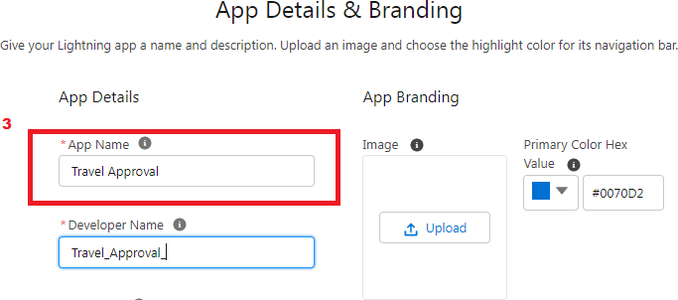  
  
  
  
  
  
  
  
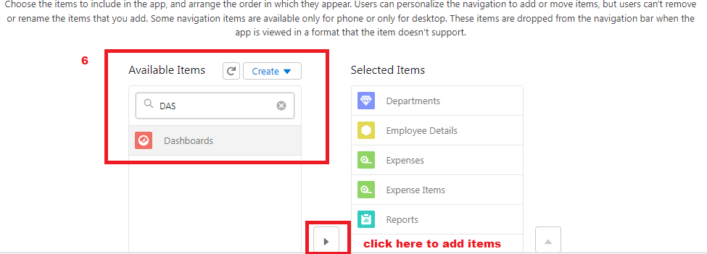  
  
  
  
  
  
  
  
  
  
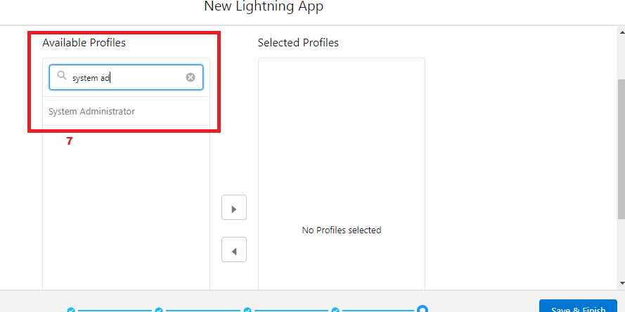  
  
To verify your changes, click the App Launcher, type **Travel Approval** and select the  
**Travel Approval** app.  
  
Note:  
App Launcher-Displays available apps.  
App Name-Displays the current selected app.

**Fields And Relationships**

**Fields**- Fields store data values that are required for a particular object in a record.   
   
An object relationship in Salesforce is a two-way association between two objects.   
Relationships are created by creating custom relationship fields on an object. This is done so that when users view records, they can also see and access related data.

**Creation Of Fields For The Department Object:**

1.Click the gear icon and select Setup. This launches Setup in a new tab.   
2.Click the Object Manager tab next to Home.   
3.Select Department   
4.Select Fields & Relationships from the left navigation   
5.Click New   
6.Select the Text as the Data Type, click Next.   
7.For Field Label, enter Department Code and enter 5 in Length.   
8.Click Next, Next, then Save & New.   
9.Follow above steps and create two more Text type field - District & State.   
10.Also, Provide Length 40 for both District and State field.   
11.Create URL type field & give “School website” as the field label.   
  
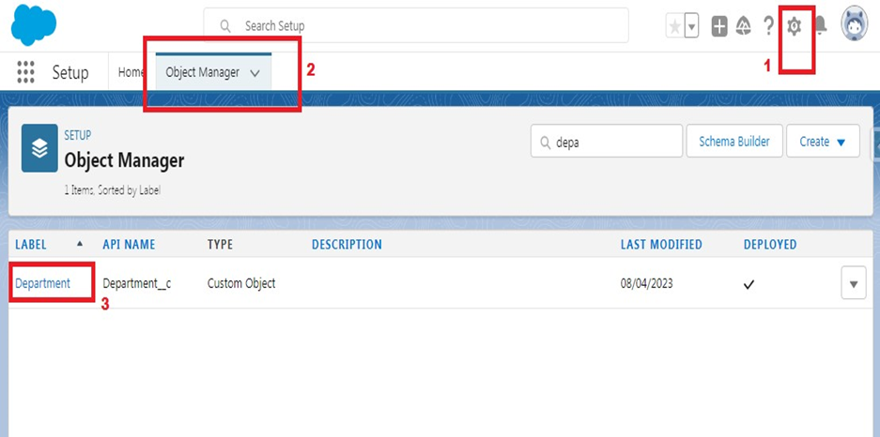  
  
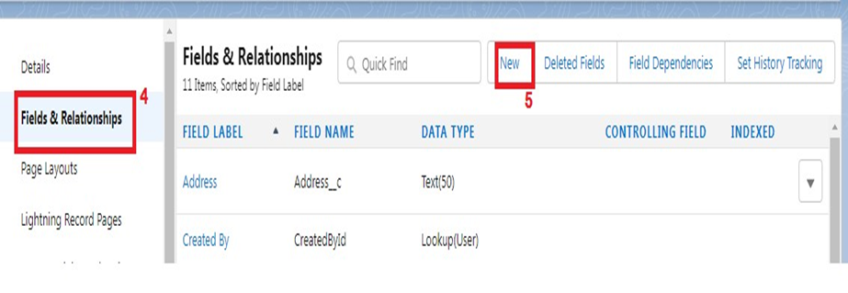  
  
  
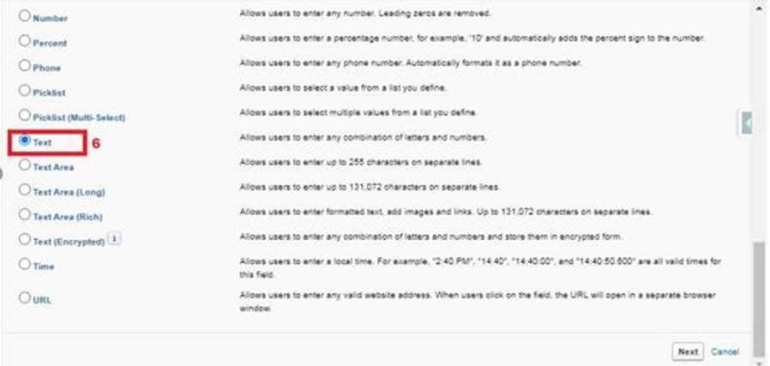  
  
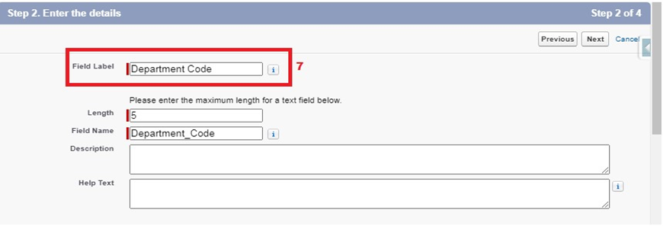  
  
Now let's create the other fields and we must choose the data types of the fields carefully.   
Let’s have a look at it.   
       
   These are fields and their data types we need to create and make one by one –   
   
   NOTE- See activity 2, 3, 4 below to create a lookup field, Roll-up summary field & Picklist field   
   
 Object Name            Field Name                           Data Type

1. Employee Detail-  Date of Birth                         Date   
                                   Gender                                  Picklist (Male, Female)   
                                   Department                          Lookup (Department)(See activity 2 to create lookup)   
                      Employee Id                         Text (Length - 12)   
          
2. Expense-              Employee                              Lookup (Employee Detail)   
                                  Total Item                               Rollup summary (Expense Item)   
          
3. Expense Item -   Expense                  Master Detail (Expense)   
                                 Expense Type          Pick List (Values are- Transport, Hotel, Meal, Others)   
               Amount                    Currency   
   
4. Travel Approval- Employee Name         Lookup (Employee Detail)   
                  Department               Lookup (Department)   
                                 Destination state        Text (Length – 40)   
              Purpose of trip          Text (Length – 256)   
              Trip start date                  Date   
              Trip End date            Date   
              Status                                Picklist (Values are- Approved, Rejected)   
   
   
        NOTE- Make Trip Start Date and Trip End Date field required when making these field

**Lookup Relationship With Department**

Let's create a Lookup relationship with Department object on Employee Detail object Follow steps 1 to 5 of field creation then follow below steps.  
Select look up Relationship as the Data Type and click Next.  
  
For Related to, enter Department.  
Click Next.  
  
For Field Label, enter Department.  
Click Next, Next, Next and Save.  
  
  
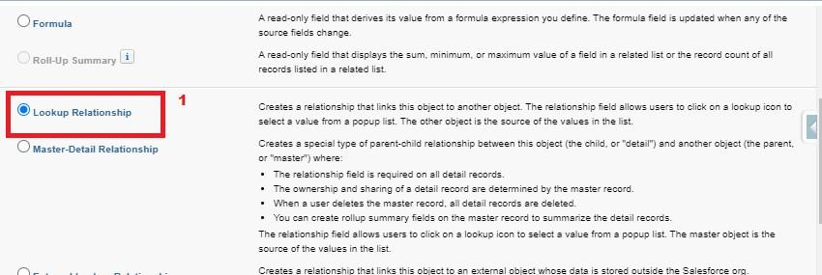  
  
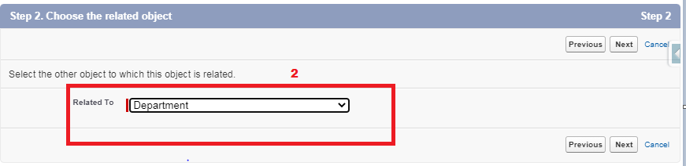  
  
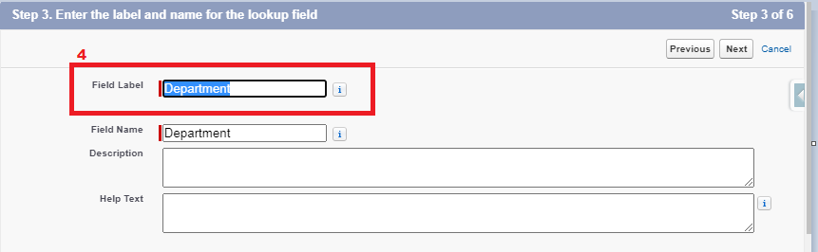  
  
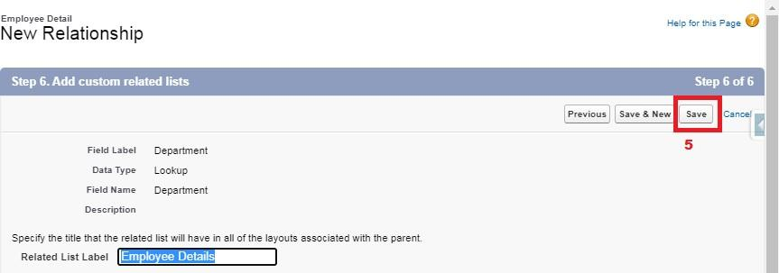  
Let's create a master-detail relationship on Expense Item object Follow steps 1 to 5 of field creation then follow below steps.  
Select Master-Detail Relationship as the Data Type and click Next.  
For Related to, enter Expense.  
Click Next.  
For Field Label, enter Expense.  
Click Next, Next, Next and Save.  
  
  
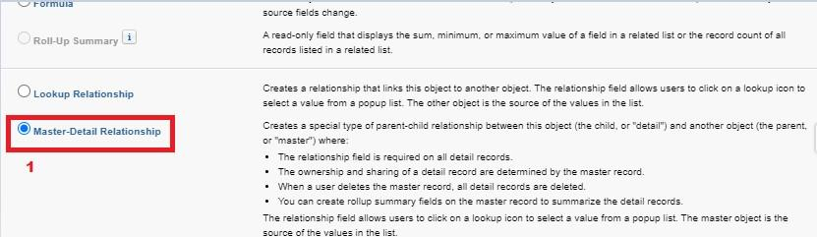  
  
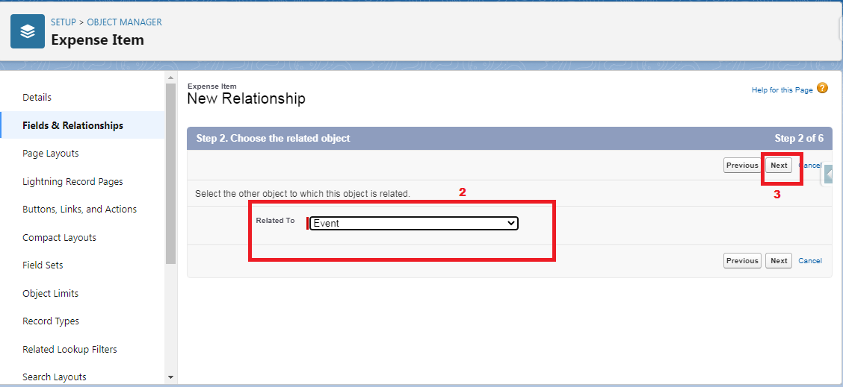

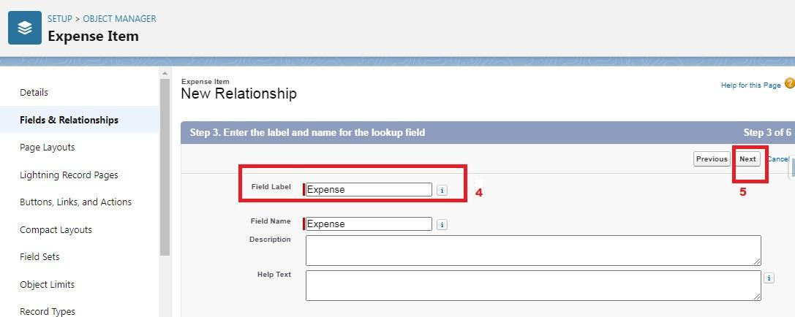

**Roll Up Summary Fields On Expense Object**

**Let’s create Roll-up summary fields on Expense Object to calculate the expense**

1. Click the gear icon Select Setup, This launches Setup in a new tab.
2. click Object Manager
3. Select Expense.
4. Click Fields & Relationships
5. Click New.

### Select the Roll-up summary field as the data type Enter the field label as Total Expense Click Next Then select the master object summarized as Expense items Select Sum as roll-up and Field to aggregate Amount then click Next, Next and save. Pick List Field

**Let’s create a Pick-List field:**  
  
1) From Setup, click Object Manager and select Expense Item.  
2)Click Fields & Relationships, then New.  
3)Select Picklist as the Data Type and click Next.  
4)For Field Label enter Expense Type  
5)Select Enter values, with each value separated by a new line, and enter these values:

* Transport
* Hotel
* Meal
* others

Click Next, Next, then Save & New  
  
  
  
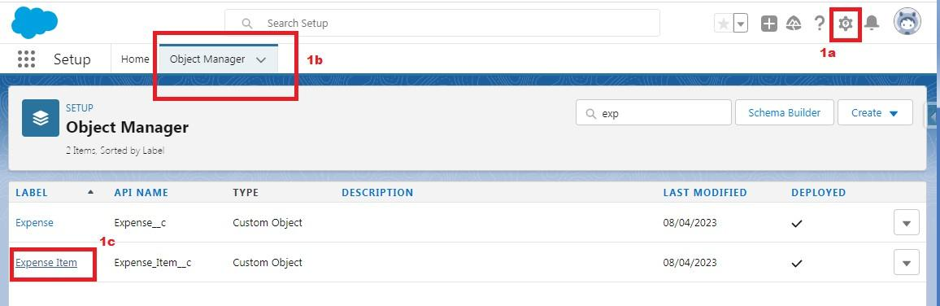  
  
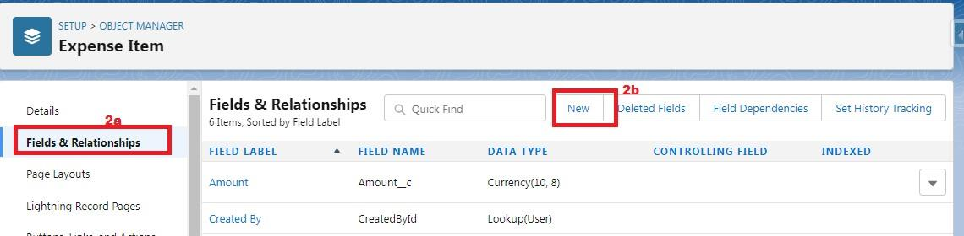  
  
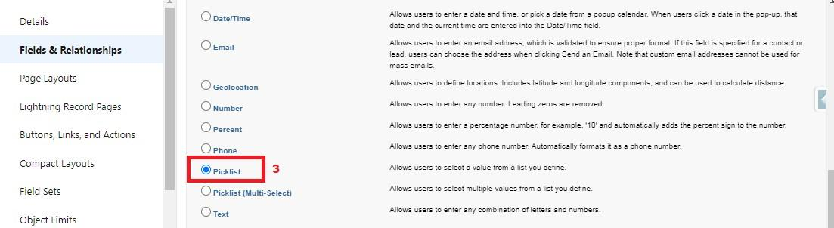  
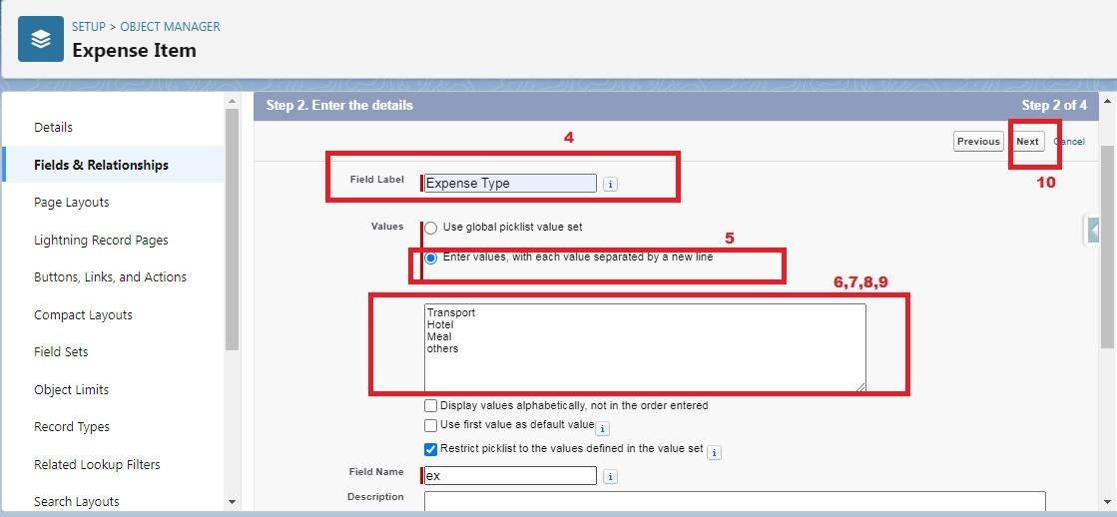

**Import Departments**

**NOTE-** Before creating the   application download this zip file  from URL given below

<https://developer.salesforce.com/files/TravelAppWorkshopFiles.zip>  
   
Data Import lets you upload data from external sources and combine it with data you collect via Analytics. You can then use Analytics to organize and analyze all of your data in ways that better reflect your business.    
   
The Data Import Wizard is a Tool that makes it easy to import data for many standard Salesforce objects, including accounts, contacts, leads, solutions, campaign members, and person accounts. You can also import data for custom objects.    
   
In order to complete this milestone, you need to create a CSV file and give them the data given in the picture below. After that from these CSV files we will import data for Department   & Travel Approval (Custom Object)   
   
1.CSV file Name- Department_CSV

 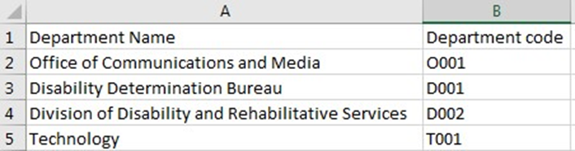

**Data Import**

From Setup, click the Home tab.  
1)In the Quick Find box, enter Data Import and select Data Import Wizard.  
2)Click Launch Wizard!  
3)Click the Custom Objects tab and select the Departments object.  
4)Select Add new records.  
5)Click CSV and choose file Department_CSV which we made earlier. Click Next.  
6)Since the field names in the CSV file (CSV Header) are the same as the field names in your object (Mapped Salesforce Object), the fields are automatically mapped. Click Next.  
  
The next screen gives you a summary of your data import. Click Start Import.  
Click OK on the popup.  
  
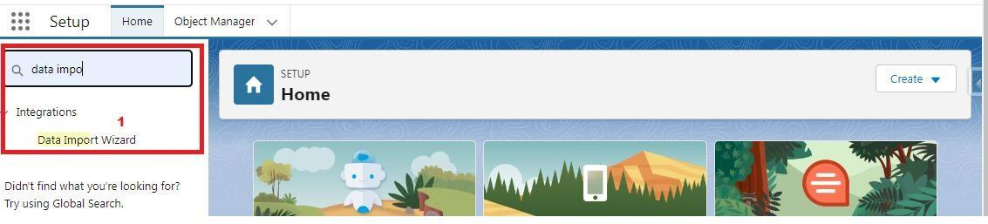  
  
  
  
  
  
  
  
  
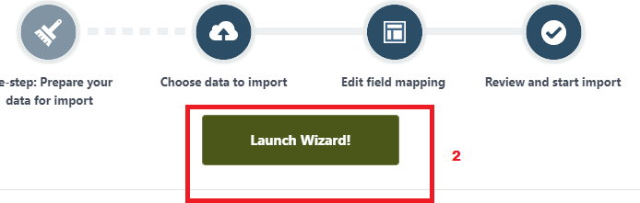  
  
  
  
  
  
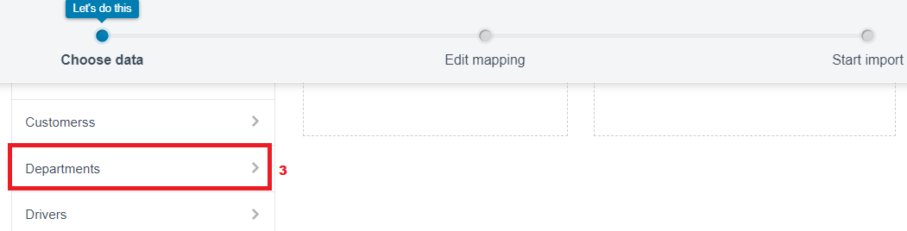  
  
  
  
  
  
  
  
  
  
  
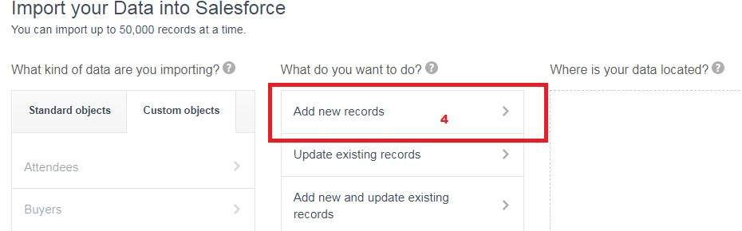  
  
  
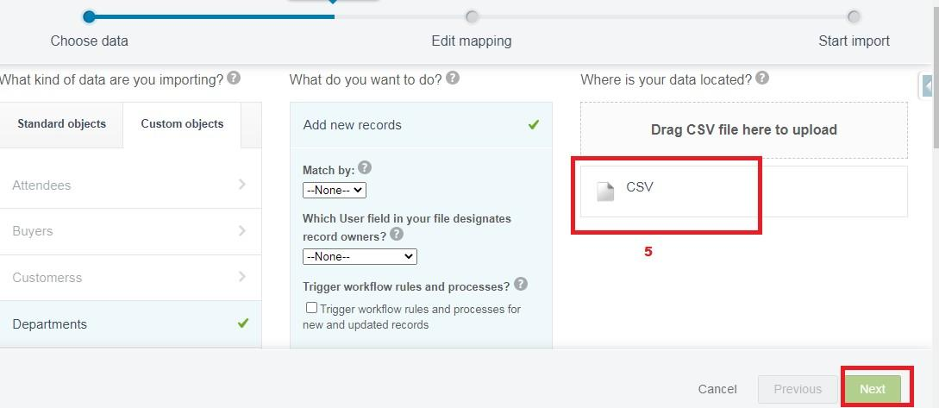  
  
  
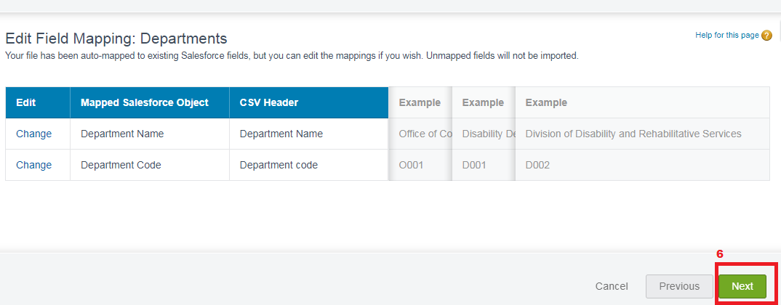  
  
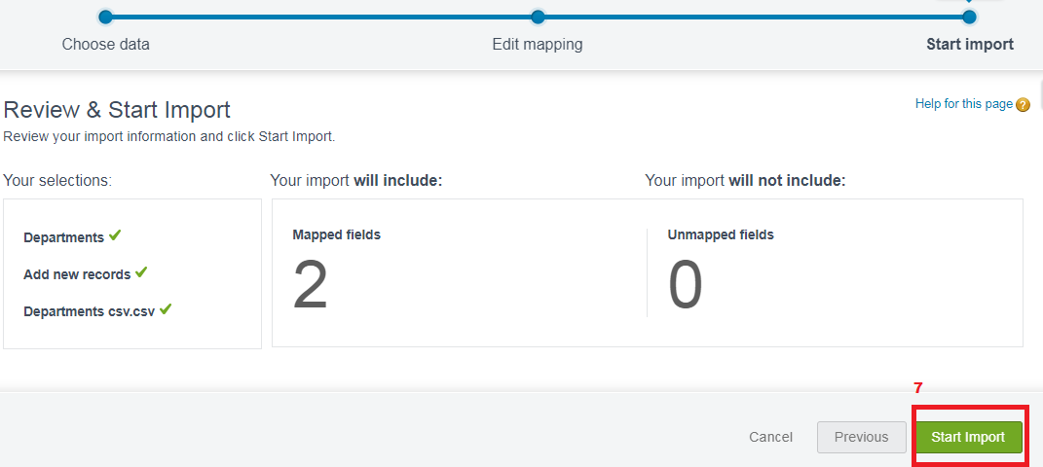  
  
  
  
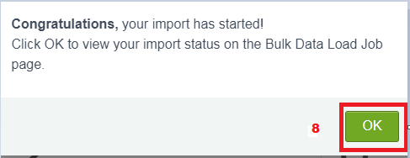  
  
  
  
**Note-** Do Field mapping carefully.

..

..

### <https://developer.salesforce.com/files/TravelAppWorkshopFiles.zip>Users

**A user is anyone who logs into Salesforce.**  
  
Users are employees at your company, such as sales reps, managers, and IT specialists, who need access to the company's records. Every user in Salesforce has a user account.

**Creating A User In Salesforce**

1.From Setup, in the Quick Find box, enter Users.   
2.Select Users.   
3.Click New User.   
4.Enter the First Name Travel Approval and Last Name manager and (Your) email address and a  unique username in the      
  form of an email address. By default, the username is the same as the email address.   
5.Select a User License as Salesforce.

  **NOTE**- *In the Developer edition  Salesforce license can only be used by 2 Users at a time in Dev Org, If you don’t find Salesforce     
  license then deactivate a user who has Salesforce license Or change the license type from Salesforce to any other.*

6.Select a profile as Standard user.   
7.Check Generate new password and notify the user immediately to have the user’s login name and a temporary password          
 emailed to your email.   
  
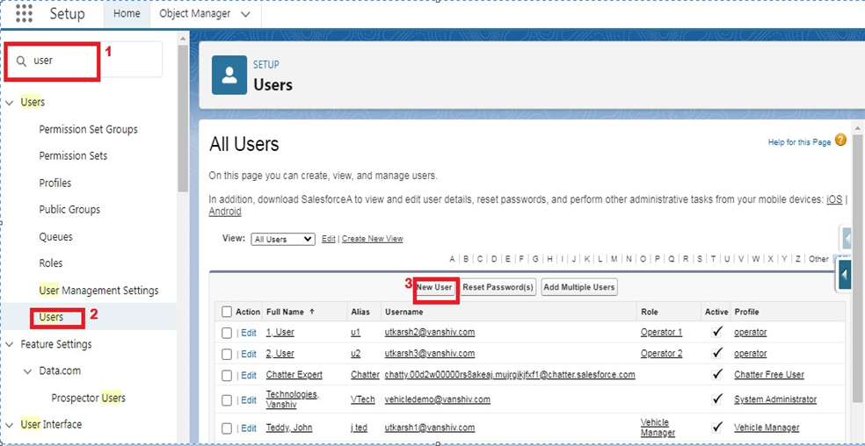  
  
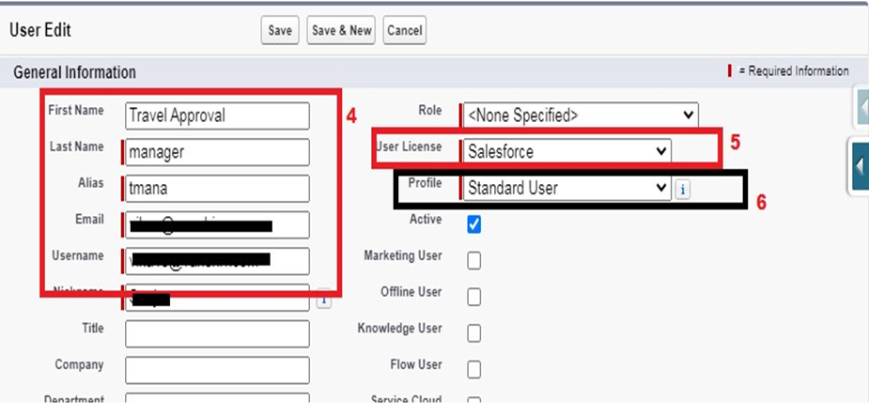

**Creating A User In Salesforce**

1.From Setup, in the Quick Find box, enter Users.   
2.Select Users.   
3.Click New User.   
4.Enter the First Name Travel Approval and Last Name manager and (Your) email address and a  unique username in the      
  form of an email address. By default, the username is the same as the email address.   
5.Select a User License as Salesforce.

  **NOTE**- *In the Developer edition  Salesforce license can only be used by 2 Users at a time in Dev Org, If you don’t find Salesforce     
  license then deactivate a user who has Salesforce license Or change the license type from Salesforce to any other.*

6.Select a profile as Standard user.   
7.Check Generate new password and notify the user immediately to have the user’s login name and a temporary password          
 emailed to your email.   
  
  
  


**Customize Travel Approval Object Page Layout**

1. From the Object Manager, search for the Travel approval object    
2. click on page layouts and  click Travel Approval Layout   
3. Drag the Section from the top pane to the lower pane directly below the Information section. When dragging over the      
  page, you get a visual indicator of where you can drop the new section.   
4. Name the section Trip Info, leave the rest of the settings at their default values, and    
5. Then click on OK.   
6. Drag Trip Start Date and Trip End Date, Status from the top pane into the left-hand column of the Trip Info   
  section.   
7. Drag the Destination State and Purpose of a trip from, department the top pane into the right-hand column of the Trip   
  Info section.   
8. Click Save.   
   
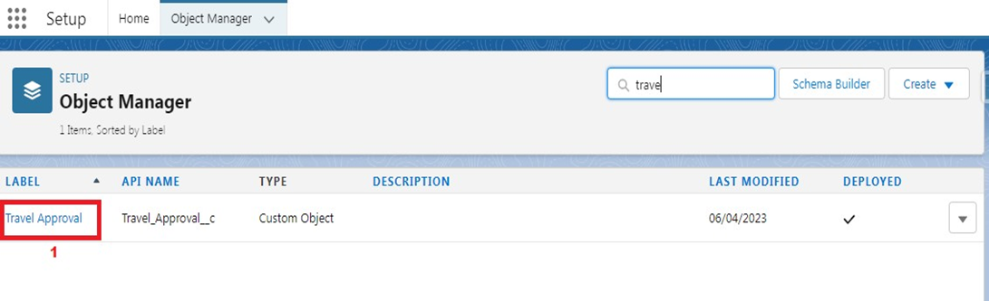  
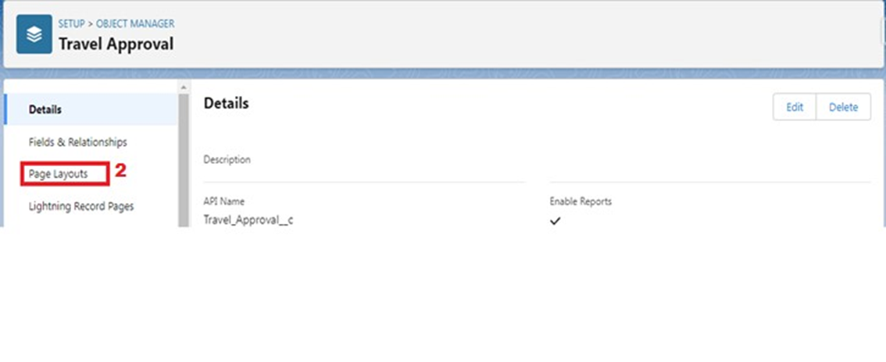  
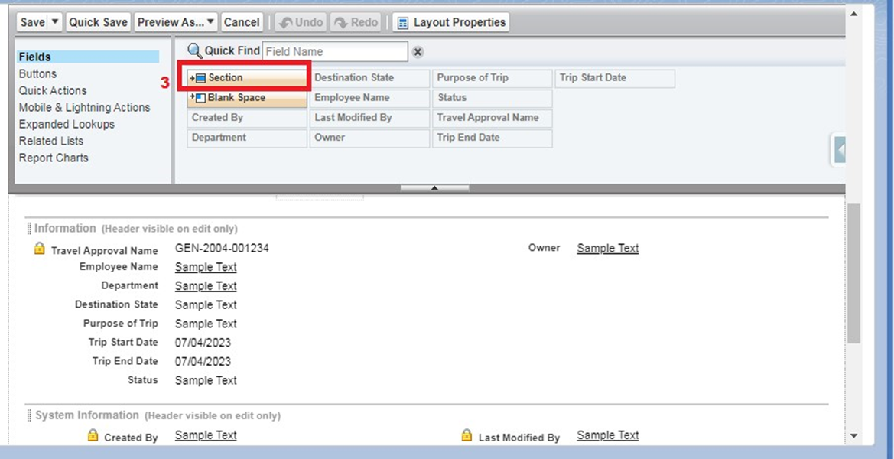

**Add Business Logic To Travel App**

**Validation Rule** - It can contain a formula or expression that evaluates the data in one or more fields & returns a value of true or false. Validation Rules also include an error message to display to the user when the rule returns a value true due to an invalid value/data.

**Create Validation Rule**

Search for the travel approval object from the object manager and open the object.  
1)Click on validation rules and click new on the left corner  
2)Give your rule name Date _Validation and make sure that the rule is set to active.  
3)In the error condition formula enter Trip_End_Date c < Trip_Start_Date   c  
NOTE- Make sure that there is no syntax error after you input this error condition  
  
Give the Error message – “Trip end date must be the date greater than the Trip start date” &  
For error location select the field and pick the Trip end date as the location for error.  
Click save  
  
  
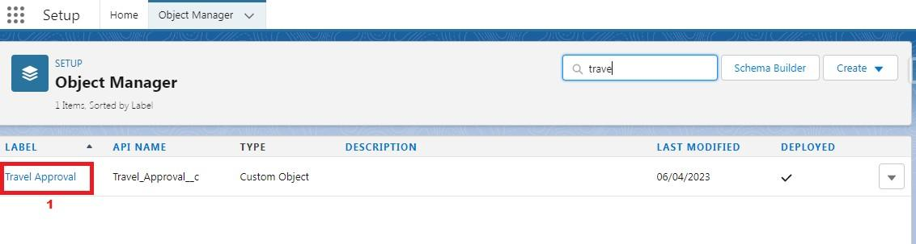  
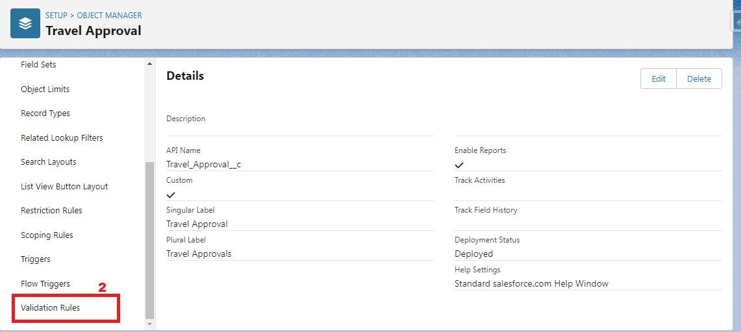  
  
  
  
  
  
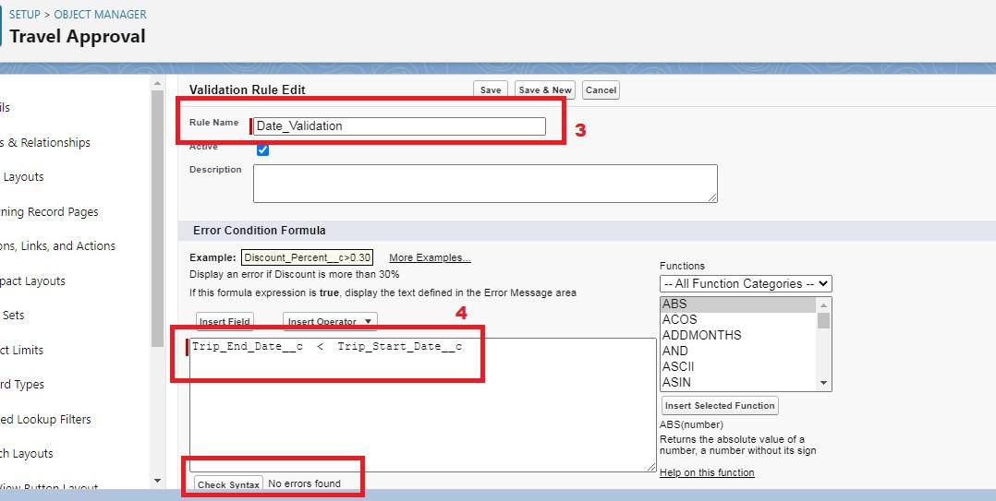  
  
  
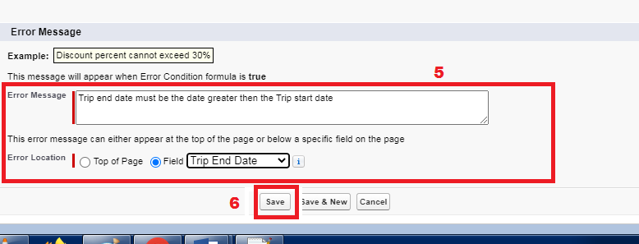

**Create Formulae Fields**

Create Formula Fields  
1)First, we need to upload a zip file to your Salesforce environment that contains all the images we use. You should have 2)a file titled StatusImages.zip.  
3)Click the setup  
4)Click Static Resources in Quick Find & Click New.  
5)Enter the following values for your static resource

|  |  |
| --- | --- |
| Parameter | Value |
| Name | StatusImages |
| File | StatusImages.zip |
| Cache-Control | Private |

Now select the travel approval object.  
Select Fields & Relationships, Click New  
Select Formula data type, and Click Next.  
Enter the following values:  
Field Label: Status Indicator  
Field Name: Status_Indicator (This automatically gets sent when you tab out of the Field Label field)  
Formula Return Type: Tex  
  
Click next & Copy and paste the following formula into the formula editor.

*IF( ISPICKVAL( Status c c, 'Approved'), IMAGE("/resource/StatusImages/thumbs-up.png", "Accepted", 20, 20),  
IF ( ISPICKVAL( Status c c, 'Rejected'), IMAGE("/resource/StatusImages/thumbs-down.png", "Rejected", 20, 20), IMAGE("/resource/StatusImages/draft.png", "In-Process", 20, 20)))*  
  
  
Click Next, Next, Save.  
  
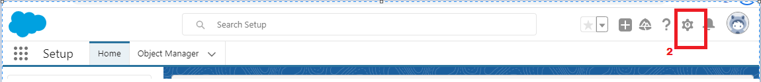  
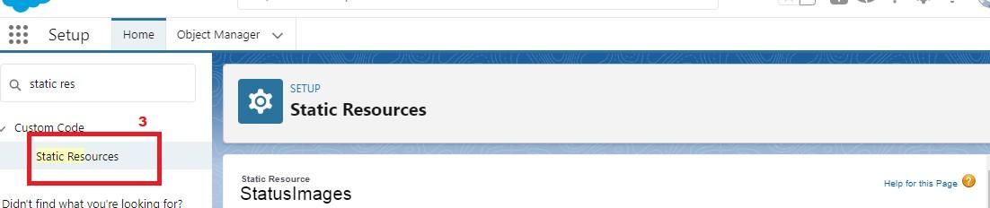  
  
  
  
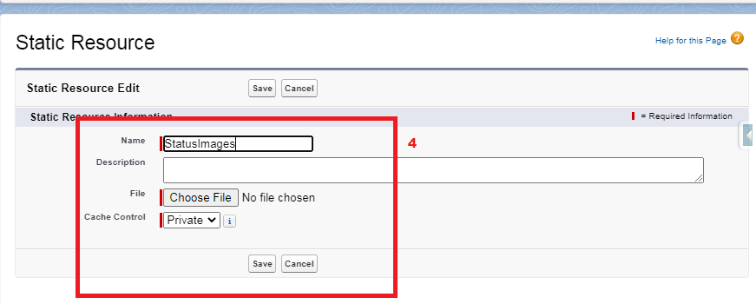  
  
  
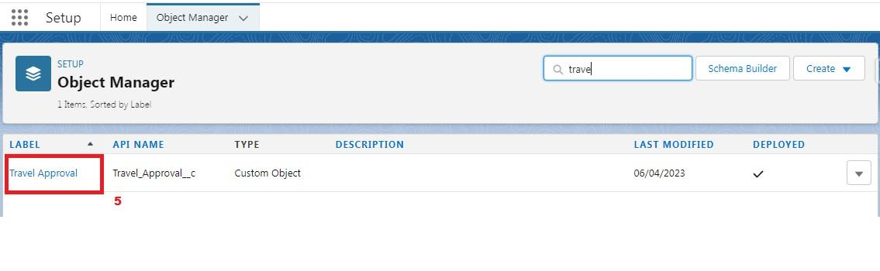  
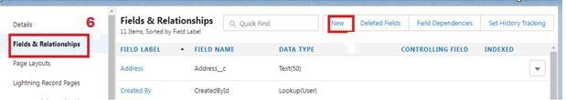  
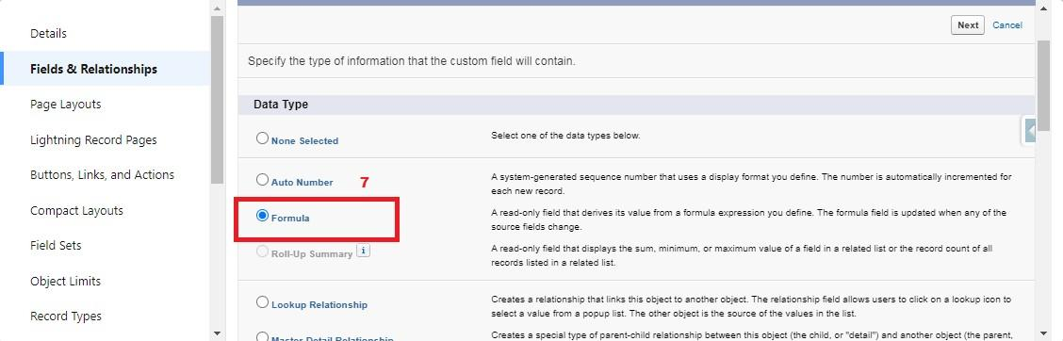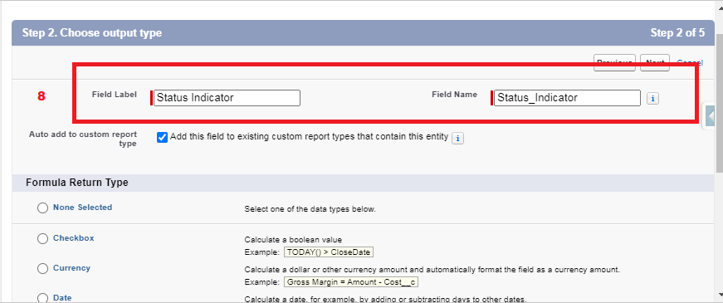  
  
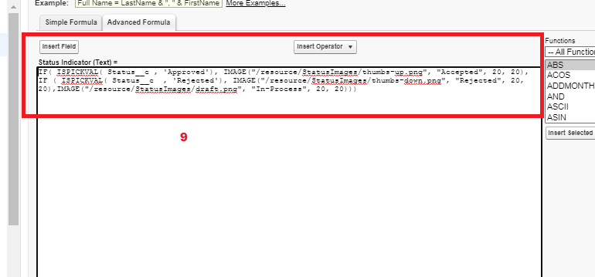

### User Adoption - Create Record

**Create Record**

Click App Launcher and select Travel Approval App  
  
1)Click reports tab  
2)Click New Report.  
3)Click the report type as Travel approval with Departments Click Start report.  
4)Customize your report, in group rows select - Department Name  
5)Click refresh  
6)Click save and run  
7)Give report name – Travel Approval Report  
8)Click Save  
  
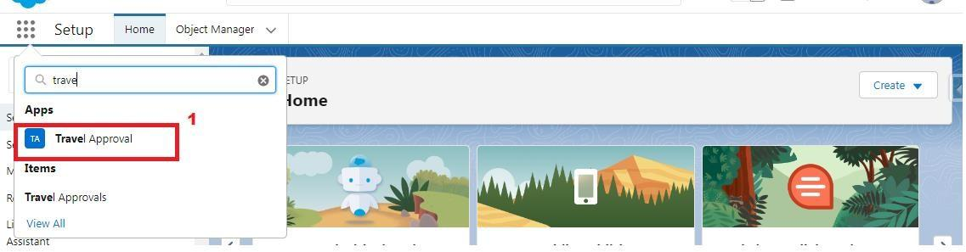  
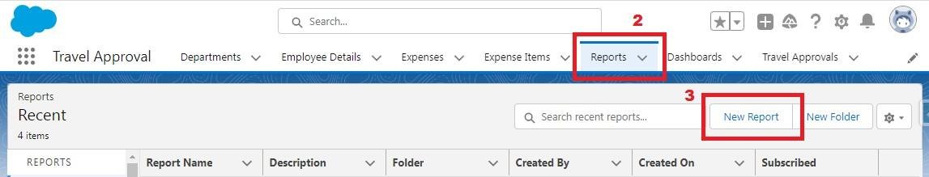  
  
  
\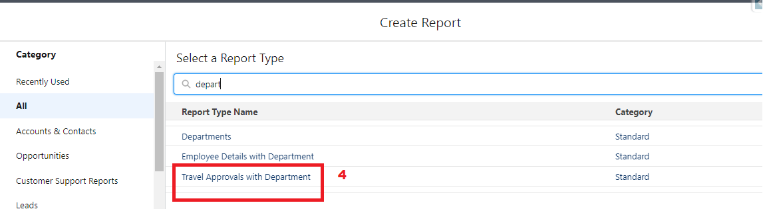  
  
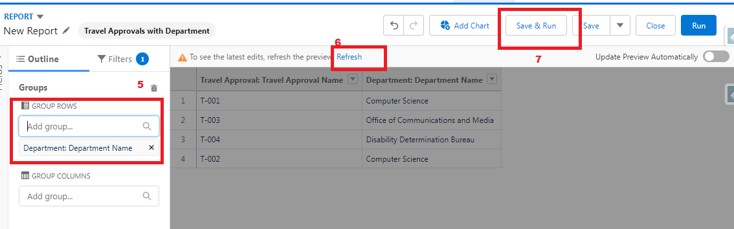

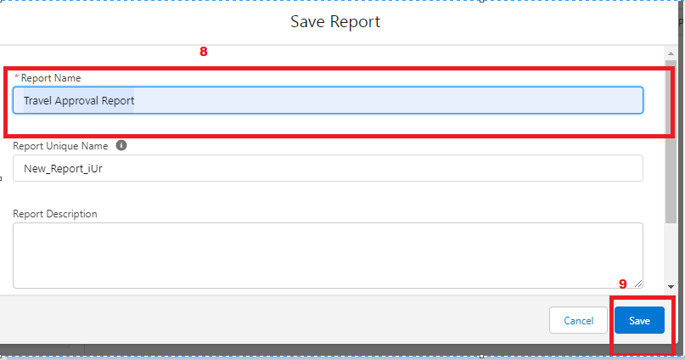

**View Record**

View Record (Department):   
1.Click on App Launcher on left side of screen.   
2.Search Travel Approval & click on it.   
3.Click on Department Tab.   
4.Click on any record name. you can see the details of the Department   
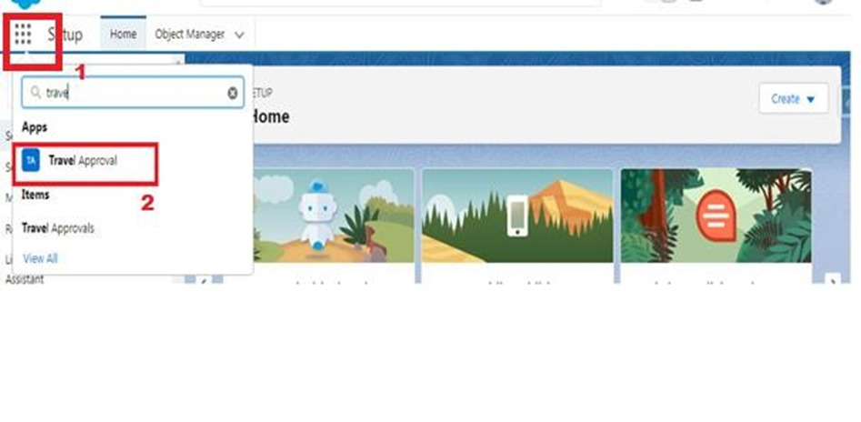  
  
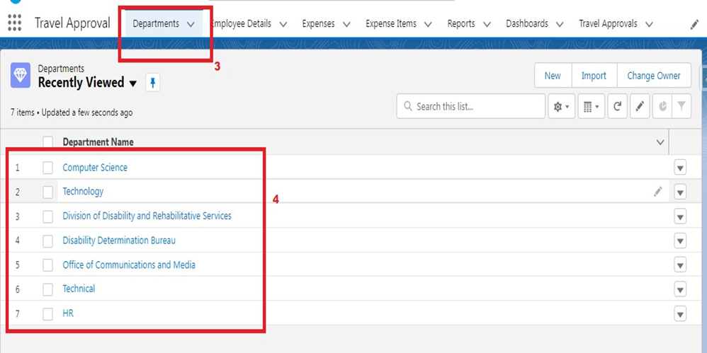

**Delete Record**

Delete Record (Department):   
   
1. Click on App Launcher on the left side of the screen.   
2. Search Travel Approval & click on it.   
3. Click on Department Tab.   
4. Click on Arrow at the right-hand side on that particular record.   
5. Click delete and delete again.   
  
  
  
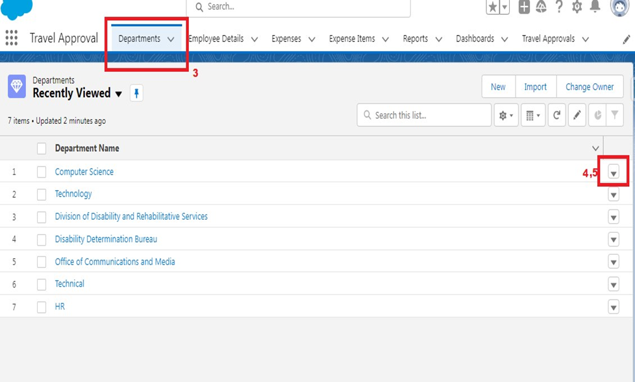

**What Are Reports?**

Reports in Salesforce is a list of records that meet a particular criterion which gives an answer to a particular question. These records are displayed as a table that can be filtered or grouped based on any field.   
   
There are 4 types of report formats in Salesforce:   
   
1.Tabular Reports:   
This is the most basic report format. It just displays the row of records in a table with a grand total. While easy to set up they can’t be used to create groups of data or charts and also cannot be used in Dashboards. They are mainly used to generate a simple list or a list with a grand total.   
2.Summary Reports:   
It is the most commonly used type of report. It allows grouping of rows of data, view subtotal, and create charts.   
3.Matrix Report:   
It is the most complex report format. Matrix report summarizes information in a grid format. It allows records to be grouped by both columns and rows. It can also be used to generate dashboards. Charts can be added to this type of report.   
4.Joined Reports:   
These types of reports let us create different views of data from multiple report types. The data is joined reports are organized in blocks. Each block acts as a subreport with its own fields, columns, sorting, and filtering. They are used to group and show data from multiple report types in different views.   
   
Report types:   
   
Report type determines which set of records will be available in a report. Every report is based on a particular report type. The report type is selected first when we create a report. Every report type has a primary object and one or more related objects. All these objects must be linked together either directly or indirectly.   
• A report type cannot include more than 4 objects.   
• Once a report is created its report type cannot be changed.   
   
There are 2 types of report types:   
   
1.Standard Report Types:   
Standard Report Types are automatically included with standard objects and also with custom objects where “Allow Reports” is checked.   
   
Standard report types cannot be customized and automatically include standard and custom fields for each object within the report type. Standard report types get created when an object is created, also when a relationship is created.   
   
Note: Standard report types always have inner joins.   
   
2.Custom Report Types:   
Custom report types are reporting templates created to streamline the reporting   
process. Custom Reports are created by an administrator or User with “Manage Custom Report   
Types” permission. Custom report types are created when standard report types cannot specify which records will be available on reports.   
   
In custom report types we can specify objects which will be available in a particular report. The primary object must have a relationship with other objects present in a report type either directly or indirectly.   
   
There are 3 types of access levels of folders:   
   
1.Viewer:   
With this access level, users can see the data in a report but cannot make any changes except cloning it into a new report.   
   
2.Editor:   
With this access level, users can view and modify the reports it contains and can also move them to/from any other folders they have access level as Editor or Manager.   
3.Manager:   
With this access level, users can do everything Viewers & Editors can do, plus they can also control other user’s access levels to this folder. Also, users with Manager Access levels can delete the report.   
From this milestone we are going to import the data and create the reports and dashboards for data visualization in the application

**Create Report**

1. Click App Launcher and select Travel Approval App    
2. Click reports tab    
3. Click New Report.   
4. Click the report type as Travel Approval with Departments Click Start Report.   
5. Customize your report, in group rows select - Department Name   
6. Click Refresh   
7. Click save and run   
8. Give report name – Travel Approval Report   
9. Click Save   
  
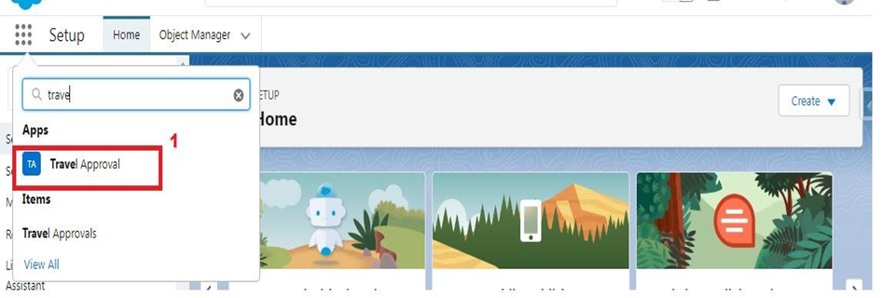  
  
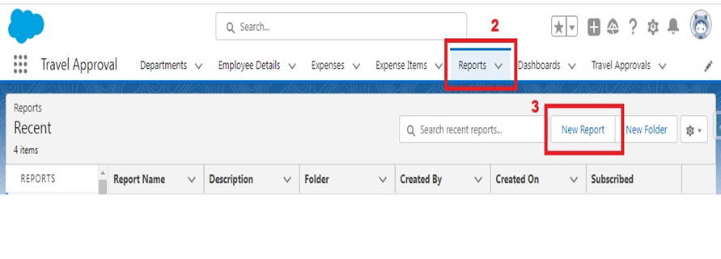  
  
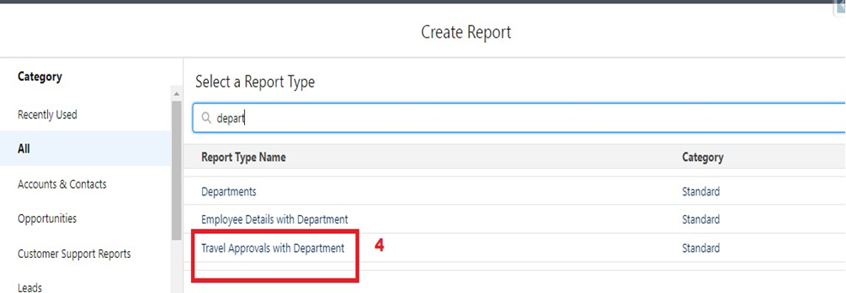

**View Report**

1.Click on App Launcher on left side of screen.   
2.Search Travel Approval App & click on it.   
3.Click on Reports Tab.   
4.Click on Travel Approval Report and see records.   
  
  
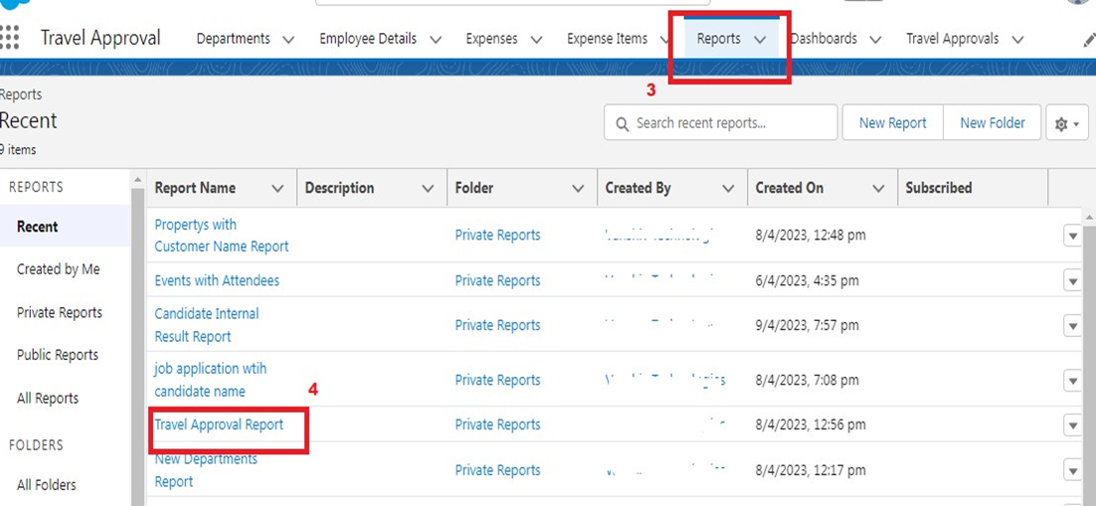

**Dashboards**

Dashboards let you curate data from reports using charts, tables, and metrics. If your colleagues need more information, then they're able to view your dashboard's data-supplying reports. Dashboard filters make it easy for users to apply different data perspectives to a single dashboard.

**Create Dashboard**

Click on the Dashboards tab from the travel approval application,  
Click on a new dashboard  
Give name- Travel Approval  
Click Create  
Give your dashboard a name and click on +component,  
select the Travel Approval Report that you created.  
For the data visualization select any of the chart, table etc as your wish.  
Click add  
Click save.  
  
  
  
  
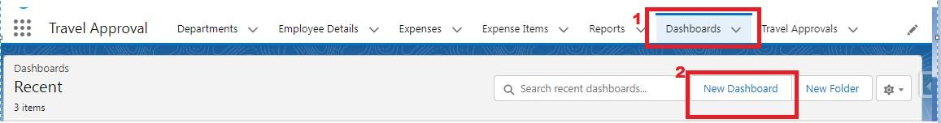  
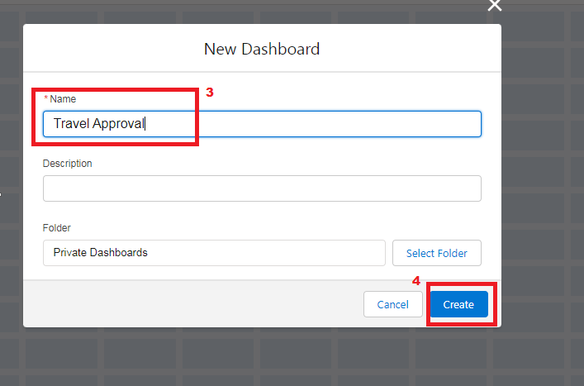  
  
  
  
  
  
  
  
  
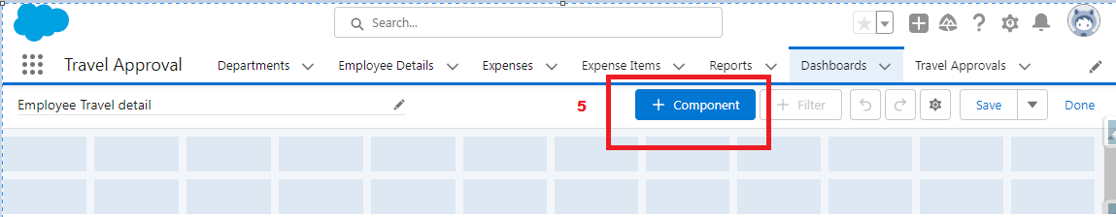  
  
  
  
  
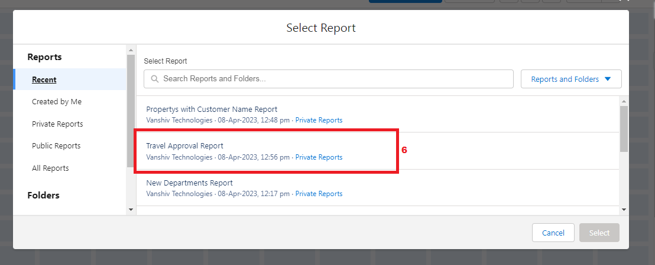  
  
  
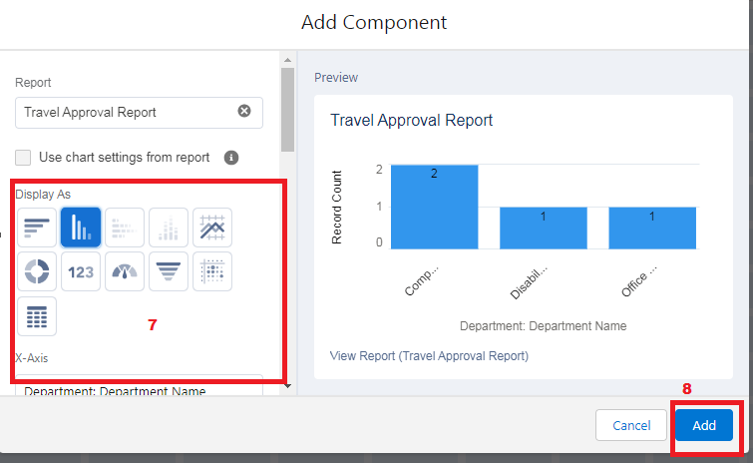  
  
  
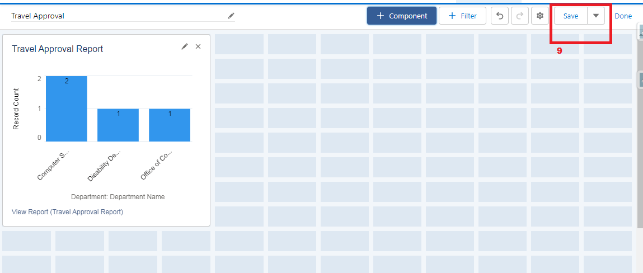

**View Dashboard**

1.Click on App Launcher on left side of screen.   
2.Search Travel Approval App & click on it.   
3.Click on Dashboard Tab.   
4.Click on Travel Approval and see graph view of records   
  
  
  
